**10 th Physics Experiments**

Experiment:- 01  
  
Title:- Ohm’s Law

Aim:- To study the dependence of potential difference (V) across a resistor on the current (I) passing through it and determine its resistance. Also plot a graph between V and I.

Apparatus:- A battery, an insulated copper wire (cut into 10 pieces), a key, an ammeter, a voltmeter, a rheostat, a resistor and a piece of sand paper.  
  
Procedure:-

1. Keep the devices as shown in the circuit diagram.
2. Connect them with the connecting wires and keep the key open.
3. Positive terminal of the battery is connected to the positive terminal of the ammeter.
4. Check the +ve and -ve terminals of voltmeter before connecting it in the circuit.
5. Once the circuit is connected, insert the key and check the rheostat, adjust its slider and see whether the ammeter and voltmeter readings are shown.
6. By using the slider of rheostat take three different readings of current 1 and voltmeter V.
7. Record your observations in the observation table.
8. Calculate resistance of a given resistor by formula R=\frac { V }{ I }.
9. Plot a graph of voltmeter reading and current reading. On x axis take V and on y axis take I.
10. Resistance increases with increase in temperature of pure metals.

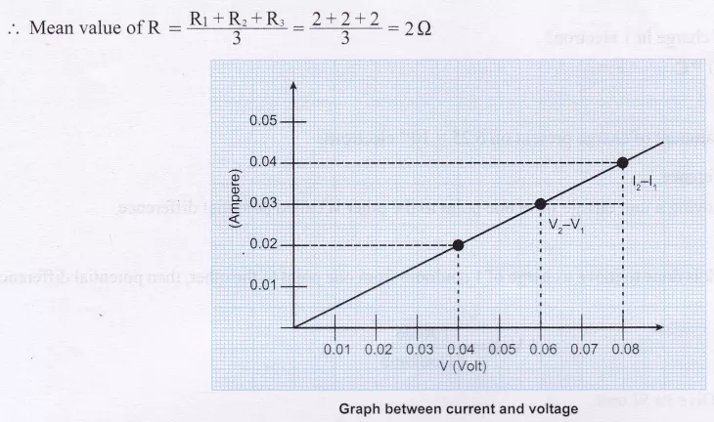

Source:- <https://www.cbsetuts.com/ncert-class-10-science-lab-manual-ohms-law/>

Experiment:- 02

Title:- Resistors in Series

Aim:- Experiment To determine the equivalent resistance of two resistors when connected in series.

Apparatus:-

* Two resistors of different values for example,  
  R, = 1 Ω, R, = 2Ω.
* Battery of 6 volt.
* Ammeter, plug key, connecting wires, a piece of sand paper, voltmeter and rheostat.

Procedure:-

1. Make the connections according to the diagram given below.
2. Do not ‘on’ the key.
3. Connect ammeter in series and voltmeter in parallel and rheostat in series in the circuit.
4. Carefully check the +ve and -ve terminals of the battery, voltmeter and ammeter, and the connections as shown in Fig. I.
5. Record the ammeter reading and the voltmeter reading by inserting the key.
6. By adjusting rheostat note three readings.
7. Now connect voltmeter in parallel one by one to individual resistance as shown in Fig. II and note down the readings.
8. Plug the key. Measure the potential difference across the first resistor. Let it be V1 .
9. Similarly, measure the potential difference across the second resistor, separately. Let the value be V2.
10. Calculate the relationship between V, V1, and V2.

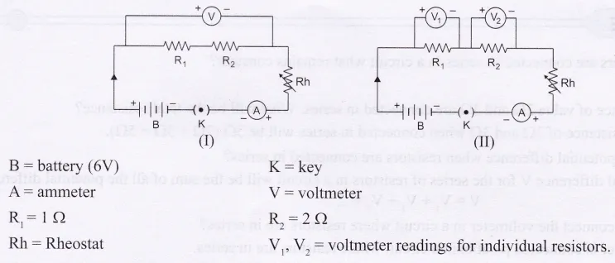

Source:- <https://www.cbsetuts.com/ncert-class-10-science-lab-manual-resistors-series/>

Experiment:- 03

Title:- Resistors in Parallel

Aim:- To determine the equivalent resistance of two resistors when connected in parallel.

Apparatus:- A battery, a plug key, connecting wires, an ammeter, a voltmeter, rheostat, a piece of sand paper and two resistors of different value.

Procedure:-

1. Keep the key off and make all the connections as shown in the given figure I.
2. When the circuit is connected appropriately insert the key.
3. Note three readings of ammeter and voltmeter for the resistors R1 and R2 separately.
4. Now connect the circuit as shown in figure II below.
5. The resistors are connected in parallel and voltmeter is also connected in parallel.
6. Use the rheostat and record three different readings of ammeter and voltmeter.
7. Remove the key.
8. Do the calculations from the observation table.

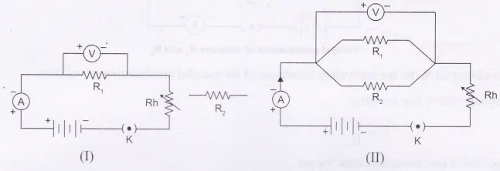

Source:- <https://www.cbsetuts.com/ncert-class-10-science-lab-manual-resistors-parallel/>

Experiment:- 04

Title:- Manual Focal Length of Concave Mirror and Convex Lens

Aim:- To determine the focal length of (i) concave mirror (ii) convex lens by obtaining the image of a distant object.

(i) To determine focal length of a given concave mirror:

Apparatus:- A concave mirror, a measuring scale, a screen a mirror holder and mirror stand.

Procedure:-

1. Select a distant object from the laboratory window (distance should be more than 50 ft).
2. Fix the concave mirror on the mirror stand placed on the table, facing the distant object.
3. Place the screen in front of the reflecting surface of the mirror. Move the screen back and forth until a clear, sharp image of the distant object is obtained on the screen.
4. Measure the distance between the concave mirror and the screen with a metre scale. This distance is the focal length of the given concave mirror. Record the focal length.
5. Repeat the above procedure twice and record the readings. Take three readings and calculate the average focal length.

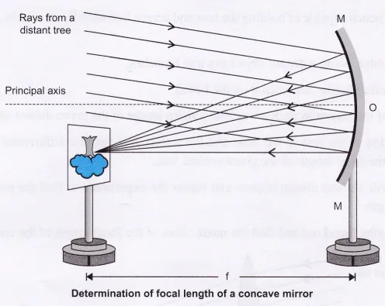

(ii) To determine focal length of a given convex mirror:

Apparatus:- Wooden bench, convex lens, a lens holder, a screen fixed to a stand, a measuring scale; etc

Procedure:-

1. Arrange the wooden bench capable of holding the lens and screen horizontally on a table, so that the lens and screen are not disturbed.
2. Keep the lens in a holder facing a distant object say tree branches.
3. Fix the screen on another holder and keep it on the bench.
4. Adjust the position of the screen in such a way that a sharp image of the given distant object falls on it.
5. Note down the position of the lens in the table and the screen, and find the differences and record the same. The difference will give the focal length of the given convex lens.
6. Focus the lens towards various distant objects and repeat the experiment to find the position of sharp image and thereby the focal length.
7. Add all the focal lengths found out and find the mean value of the focal length of the convex lens.

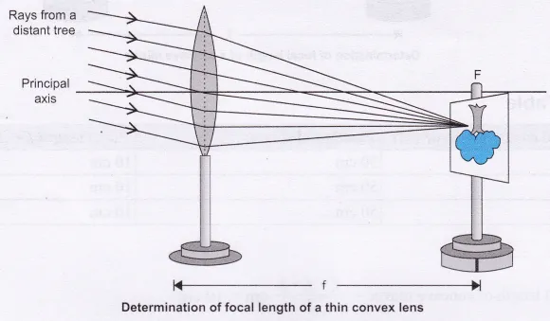

Source:- <https://www.cbsetuts.com/ncert-class-10-science-lab-manual-focal-length-concave-mirror-convex-lens/>

Experiment:- 05

Title:- Refraction Through Glass Slab

Aim:- To trace the path of a ray of light passing through a rectangular glass slab for different angles of incidence. Measure the angle of incidence, angle of refraction, angle of emergence and interpret the result.

Apparatus:- A drawing board, 4-6 all pins, white sheet of paper, rectangular glass slab, a protractor, a scale, a pencil and thumb pins.

Procedure:-

1. Take a soft drawing board. Fix a white sheet on it with the help of thumb pins.
2. Place the rectangular glass slab in the centre of the white paper and draw its outline boundary with pencil.
3. Mark this rectangular figure obtained as ABCD.
4. On one side of this figure, i.e., AB take one point E, draw a perpendicular EN and label it as normal ray.
5. With the help of a protractor draw one angle of 30° with the EN. Fix two pins P and Q on the ray of this angle, the distance between the pins should be more than 4-5 cm.
6. Put the glass slab on the rectangular figure ABCD.
7. See through the glass slab from side CD and fix pin R and S such that when seen through the glass slab all  
   the pins lie in straight line, [i.e., Pins P, Q, R and S should lie in straight line when seen through the glass slab], ‘
8. Now, remove the pins P, Q, R and S one by one and draw small circles around the pin points.
9. Remove the glass slab.
10. Join points R and S such that it meets CD at point F.  
    Draw perpendicular to CD at point F as N’M’.
11. Join points E and F with the pencil.
12. Measure the angles formed at AB and CD, i.e., the incident angle, refracted angle and emergent angle.
13. Extend ray PQ with scale and pencil in dotted line. It will be parallel to ray FRS. The distance between these two parallel rays is called lateral displacement (d).
14. Measure the lateral displacement.
15. Repeat the above procedure for angles 45° and 60°.

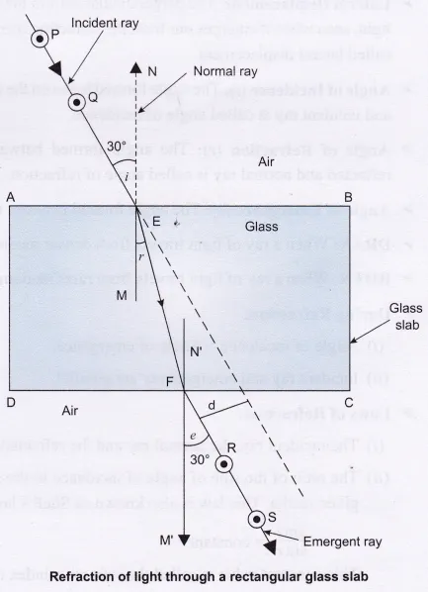

ABCD = Glass slab

EN and FM’ = Normal rays

P, Q, R, S = All pins ∠PEN = ∠i = incident angle = 30°

∠MEF = ∠r = refracted angle

∠SFM’= ∠e = emergent angle = 30° ~ 31°

d = lateral displacement.

Source:- <https://www.cbsetuts.com/ncert-class-10-science-lab-manual-refraction-glass-slab/>

Experiment:- 06

Title:- Refraction Through Prism Experiment

Aim:- To trace the path of the rays of light through a glass prism.

Apparatus:- A white sheet, soft board, thumb pins, 4-6 all pins, prism, pencil, scale, protractor, drawing board.

Procedure:-

1. Fix a white sheet on a drawing board using drawing pins.
2. Place a glass prism on it in such a way that it rests on its triangular base. Trace the outline of the prism using a pencil.
3. Draw a thin line NEN normal (perpendicular) to face AB of the prism. Also draw a straight line PE making an angle preferably between 30° and 60° as shown in figure.
4. Fix two pins at a distance of 5 cm from each other on the line PE as shown in the figure, later mark these points of pins as P and Q.
5. Look at the images of the pins, fixed at P and Q, through the other face of the prism, i.e., AC.
6. Fix two more pins, at points R and S vertically such that the feet of pins at R and S appear to be on the same straight line as the feet of the images of the pins P and Q when viewed through the face AC of the prism.
7. Remove the pins and the glass prism.
8. Join and produce a line joining R and S, let this line meet the prism at point F.
9. Extend the direction of incident ray PQE till it meets the face AC. Also extend (backwards) the emergent ray SRF so that these two lines meet at a point G.
10. Mark the angle of incidence ∠i, angle of refraction ∠r and the angle of emergence ∠e and ∠D as shown in the figure.
11. Repeat the experiment for more angle of incidence preferably between 30° and 60°.

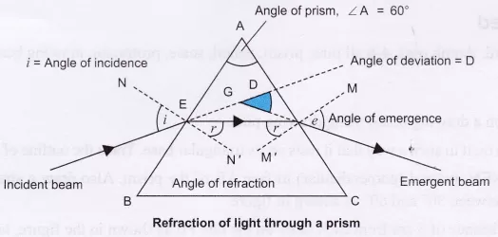

Source:- <https://www.cbsetuts.com/ncert-class-10-science-lab-manual-refraction-prism/>

Experiment:- 07

Title:- Image Formation By Convex Lens

Aim:- To find the image distance for varying object distances in case of a convex lens and draw corresponding ray diagrams to show the nature of image formed.

Apparatus:- A convex lens of a short focal length (12-20 cm), measuring scale, optical bench and a needle or a candle.

Procedure:-

1. Fix a thin convex lens on a lens holder and place the screen on the other side of the lens.
2. Focus a sharp, clear and inverted image of the distant object on the screen. This is the rough focal length, measure it with the help of a metre scale.
3. Mark the position of lens on optical bench or on a table. Fix the lens at this point, label it as ‘O’.
4. Mark a point ‘F’ at both the sides of the lens as focus of the lens by knowing the focal length as calculated in first step.
5. Mark a point 2F at both the sides of the lens, the distance of 2F from the lens is double the focal length of the lens.  
   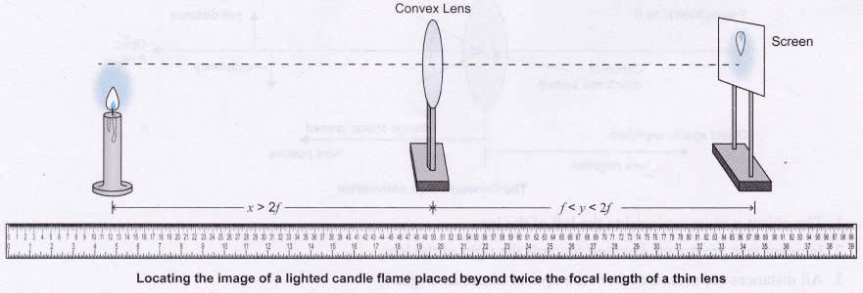**To Study The Nature And Size Of The Image Formed By A Convex Lens Using A Candle And A Screen**
6. Place a candle on the table or needle on optical bench at distance beyond 2F and adjust the height of the centre of lens nearly equal to the height of the flame of the candle.
7. To locate a sharp image of the candle flame in the convex lens from the other side of the lens, adjust the position of the screen and record your observations.
8. Now, place the object, e., the lighted candle or the needle at 2F and record your observations.
9. Now, shift the object between F and 2F and record the observations.
10. Now, place the object at F and record the observations.
11. Place the object between O and F of the lens and record your observations.
12. Draw ray diagrams for all the positions of the object.  
    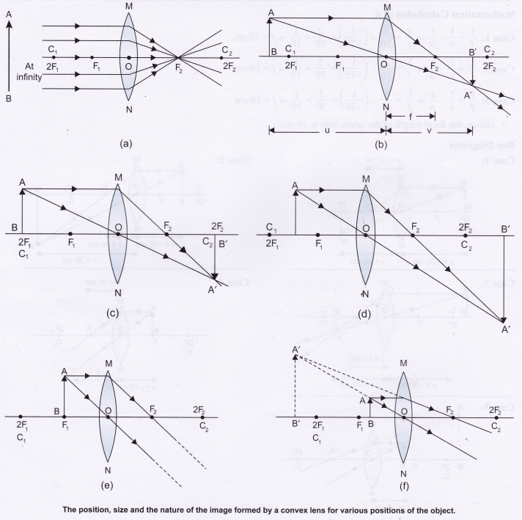

Source:- <https://www.cbsetuts.com/ncert-class-10-science-lab-manual-image-formation-by-a-convex-lens/>

*END*